Creating Submodule in git

**Step1:** Create two Repositories in git with name Devops and Developer with Readme, gitignor file.

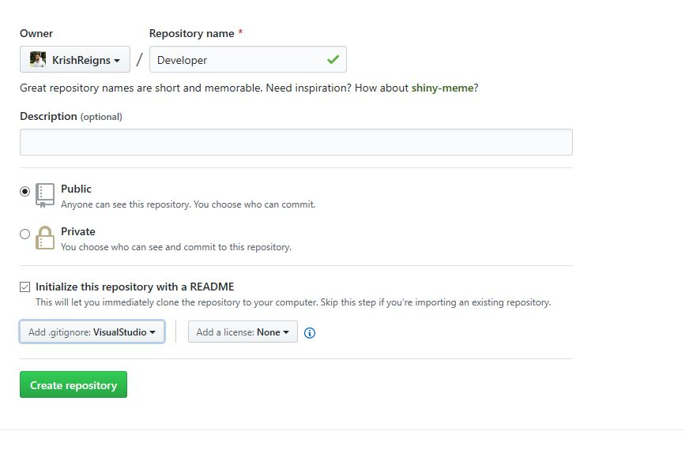

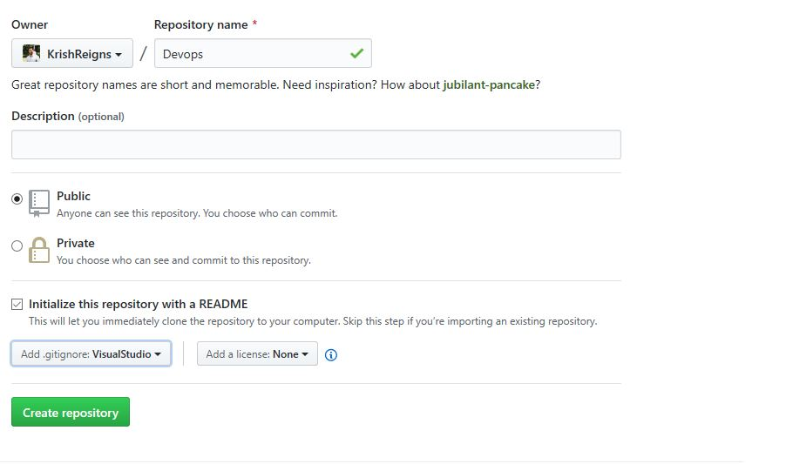

**Step2:** Create Submodule in Developer Repository by executing below command.

git submodule add -f -b master SubmoduleBranch

git add .

git commit -m “message”

git push origin master

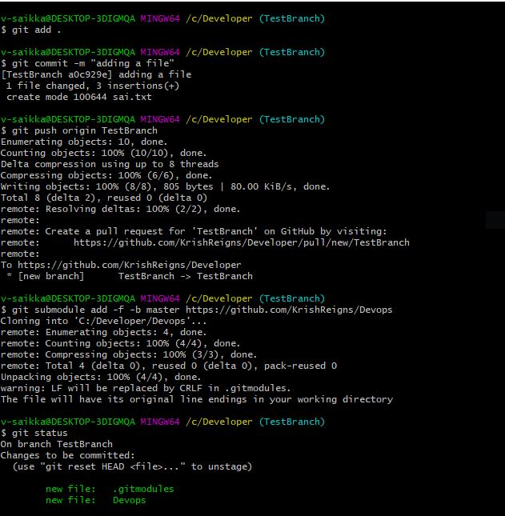

* Submodule will be created in Developer.

**Step3:** Add

[Dd]eveloper

[Dd]eveloper/** in gitignore file.

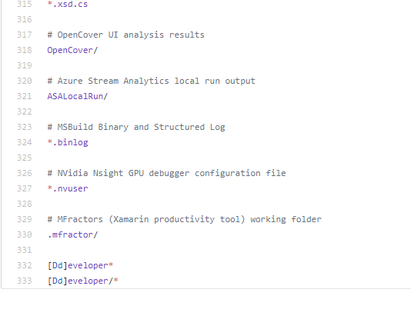

**Step4:** Add/Modify in DevOps Repository and execute below commands.

git add .

git commit -m “txt file added”

git push origin master

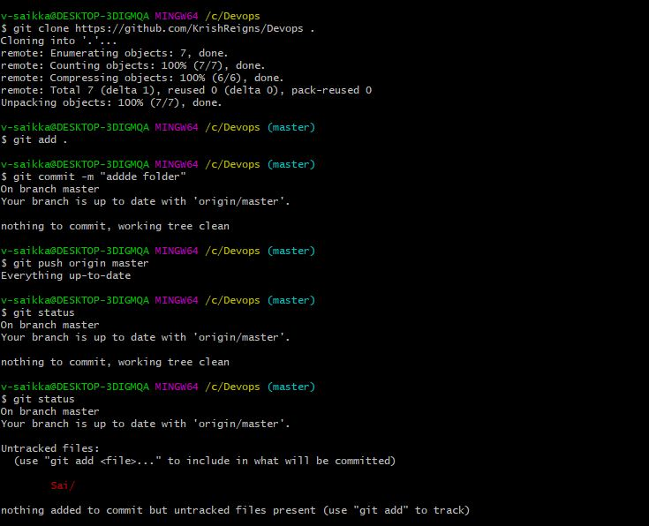

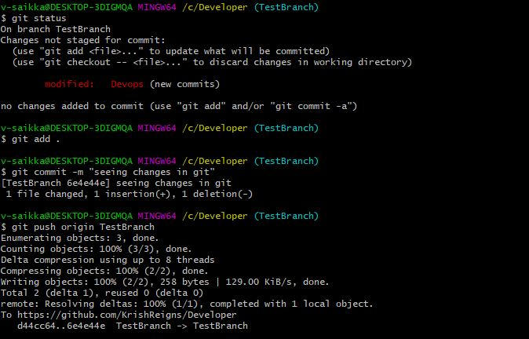

**Step5:** Execute the below commands in Developer Repository.

git submodule update --recursive --init

git submodule foreach git pull origin master

